Information System
Name
Institutional Affiliation
Course Code
Date

Information System
Describe the basic concepts of information systems (IS)
An information system (IS) refers to a consolidated set of different components for processing, storing, and collecting data as well as for digital products, knowledge, and delivering information. Information System usually uses the data kept in the computer databases to offer the required information. A database is a systematic collection of interconnected data reflecting a significant aspect of the business operations of an organization (O'brien, 2012). Therefore, Information System is essential for business entities because it captures both external data and internal data and store them in a computer database over an extensive period and when a piece of particular information is required, qualified data items are appropriately manipulated, and the managers receive the resulting information for proper decision making.
Components of Information System
Information systems usually consist of the following components: procedures, human resource, databases, software, and hardware.
Hardware
Hardware refers to multiple computers systems: mainframes, minicomputers, microcomputers, alongside their peripherals. Computer system components include output and input devices, memory hierarchy. And the central processor(s) (O'brien, 2012).
Procedures
Procedures are methods and policies need to be followed in maintaining, operating, and using the information system. Various specifications for the maintenance, operation, and use of the information systems, obtained from operator manuals, user manuals as well as help facilities.
Human resource
Information systems professionals and experts include operators, programmers, system analysts, maintenance and development managers, usually with highly specialized knowledge and skills.
Software
Computer software is classified into two categories: application software and system software. Application software is different programs which directly help the end users in performing their tasks and usually bought as packages ready-to-use (O'brien, 2012). On the other hand, system software simplifies the programming process as well as manage and control computer system resources.
Database
Databases are a systematic collection of interconnected data utilized by the application software. Computers databases are often managed and controlled by software systems, commonly called database management systems.
Evaluate the role of information systems in supporting organizational goals and provide examples where appropriate
There are several types of information systems used by business organizations, and every system plays a different role. For instance, the business intelligence system can manipulate data and convert it into valuable insights (Bargshady, 2015).Business intelligence (BI) enhance the more efficient allocation of resources and better business decisions as well as allow for more accurate, and faster reporting (Bargshady, 2015). Additionally, BI provides the organizations with data visualization, that allows the business analysts to interpret vast volumes of data, and predict the future patterns and events.
Companies can also adopt enterprise resource planning (ERP) system to manage, collect, and analyze information across various areas such as accounting, logistics and supply chain management, finance, manufacturing, production planning, marketing and sales, human resource management, and inventory control (O'Leary, 2013).Also, the ERP system help business entities to share data across all departments, increase information security as well as achieve regulatory compliance (O'Leary, 2013)
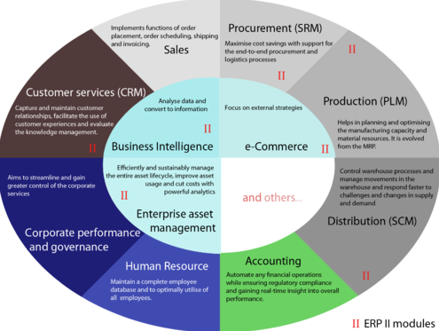
Figure 1: EPR system (O'Leary, 2013)
Conclusion
Information systems are crucial for the business organization since it collects, disseminates and store information from the company's internal operations and environment to support visualization, analysis, coordination, control, communication, decision making, organizational processes.Additionally, information systems serve as tools for value-adding operations for distributing, transforming and acquiring information to enhance organizational performance, improve decision making, and ultimately increase the organization’s profitability

References
Bargshady, G., (2015). Business Intelligence Technology Implementation Readiness Factors. Journal Technology, 68(3), 120-350. doi:https://doi.org/10.11113/jt.v68.2922
O'brien, J., (2012). Introduction to information systems. McGraw-Hill.
O'Leary, D., (2013). Enterprise resource planning systems: systems, life cycle, electronic commerce, and risk. Cambridge university press.

